CODE:

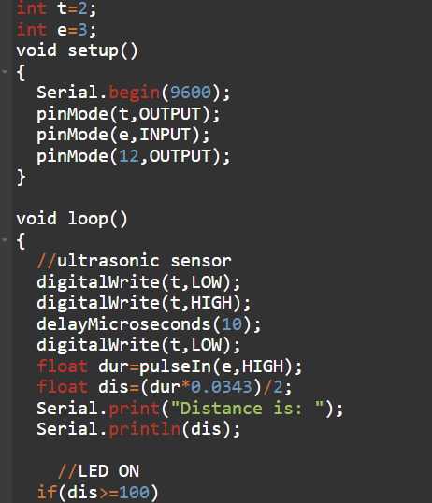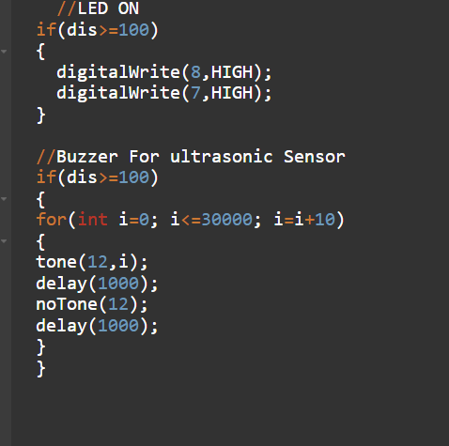

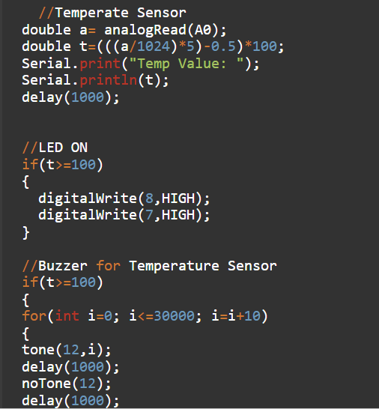

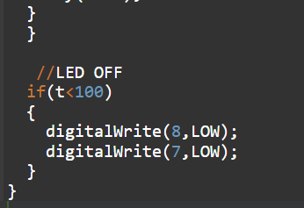

int t=2;

int e=3;

void setup()

Serial.begin(9600);

pinMode(t,OUTPUT);

pinMode(e, INPUT);

pinMode(12,OUTPUT);

void loop() //ultrasonic sensor digitalWrite(t,LOW);

digitalWrite(t,HIGH);

delayMicroseconds(10);

digitalWrite(t, LOW);

float dur=pulseIn(e, HIGH);

float dis=(dur\*0.0343)/2; Serial.print("Distance is: "); Serial.println(dis);

//LED ON if(dis >=100)

//LED ON if(dis >=100)

digitalWrite(8,HIGH);

digitalWrite(7,HIGH); 7/Buzzer For ultrasonic Sensor if(dis >=100)

for(int i=0; i<=30000; i=i+10) tone(12,i); delay(1000); noTone(12); delay(1000);

//Temperate Sensor double a= analogRead(AD):

//Temperate Sensor double a= analogRead(AO); double t=(((a/1024)\*5) -0.5) \*100;

Serial.print("Temp Value: ");

Serial.println(t); delay(1000); //LED ON if(t>=100) digitalWrite(8,HIGH);

digitalWrite(7,HIGH); 7/Buzzer for Temperature Sensor

if(t>=100) for(int i=0; i<=30000; i=i+10), tone(12, i); delay(1000); noTone (12); delay(1000);

//LED OFF if(t<100)

digitalWrite(8,LOW); digitalWrite(7,LOW);

OUTPUT:

